

**COMP1842**

**Web Programming 2**

**Student’s Name**: Vu Thanh Nguyen

**Student’s ID**: GCH221117

**Submission Date**: 24/04/2025

1. **Introduction:**

This report presents the design and implementation of a modern web application developed for a homestay booking platform. The system is structured around a full-stack JavaScript architecture, leveraging various technologies for building both the frontend and backend, as well as managing data and user interactions efficiently.

The backend is built with **Node.js**, a powerful runtime environment that enables the development of scalable server-side applications. Using **Express.js**, a minimalist and flexible web framework, the project constructs robust RESTful APIs to handle client-server communication. **MongoDB**, a NoSQL database, is employed to store application data, while **Mongoose** serves as the Object Data Modeling (ODM) library to facilitate schema definition and interaction with the MongoDB database.

For image management, the system integrates **Cloudinary**, a cloud-based solution that supports image uploading, transformation, and storage. **Multer** is used as middleware to handle file uploads from client devices. To secure user information, **Bcrypt** is applied for password hashing, and **JWT (jsonwebtoken)** is used for token-based authentication, ensuring data integrity and secure access control. Additionally, **Validator** is employed to verify the correctness and safety of user input.

On the frontend, the application utilizes **React**, a widely-used JavaScript library for building dynamic and responsive user interfaces. To streamline development and optimize performance, **Vite** is adopted as the build tool. For styling, **Tailwind CSS** provides a utility-first approach, enabling rapid and consistent design across components.

Overall, the technologies chosen for this project contribute to a modular, secure, and scalable web application that delivers an efficient and user-friendly experience.

1. **RDBMS & NoSQL comparison:**
2. **Introduce, analyze & evaluate RDBMS:**

**RDBMS** is a **relational database management system** that stores data in the form of tables, each table has rows and columns. Popular RDBMS systems include: MySQL, PostgreSQL, Oracle, SQL Server.

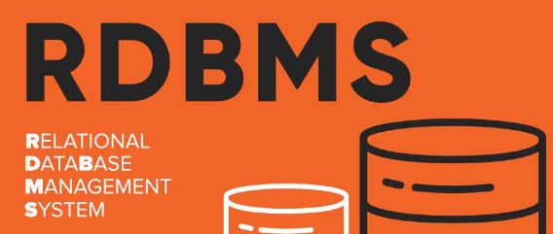

*Figure 1: Relational database management system*

**Analysis**

* Data structure: Data is tightly organized according to the relational model. Tables can be linked together by foreign keys.
* Data integrity: Supports ACID (Atomicity, Consistency, Isolation, Durability) very well — ensuring accurate and consistent transactions.
* Query language: Uses standard SQL (Structured Query Language) to query and manipulate data.
* Scalability: Mainly vertical scale (increase server resources), so it is difficult to scale when the amount of data is extremely large.
* Structured data: Suitable for data with clear structure, little change in format.

**Evaluation**

* Advantages:

High consistency and securit , good support for complex queries and have any tools and support communities

* Disadvantages:

Less flexibility with unstructured data, difficult to scale horizontally and it can be slow when processing large, complex data

1. **Introduce, analyze & evaluate NoSQL:**

**NoSQL** is a **non-relational database system** designed to handle large amounts of data, unstructured or semi-structured data, often used in distributed and real-time systems. Popular types of NoSQL:

* Document-based (MongoDB)
* Key-Value (Redis)
* Column-based (Cassandra)
* Graph-based (Neo4j)



*Figure 2: Non-relational database system*

**Analysis**

* Data structure: Flexible, no need for fixed schema, easy to store data in different formats.
* Scalability: Scale horizontal — easy to expand by adding servers (sharding).
* Consistency: Does not strictly adhere to ACID but tends to the BASE model (Basically Available, Soft state, Eventually consistent).
* High performance: Optimized for large read/write, real-time applications.
* Data query: Does not use standard SQL, each type of NoSQL has its own query method.

**Evaluation**

Advantages:

* Flexible with all types of data
* Easily scalable and high performance
* Suitable for Big Data and distributed systems

Disadvantages:

* Does not support complex queries well
* Consistency is not as high as RDBMS
* Each system has its own syntax and structure, making it difficult to learn

1. **Comparison between RDBMS and NoSQL**

| **Criteria** | **RDBMS** | **NoSQL** |
| --- | --- | --- |
| **Data Model** | Tables | Document, Key-Value, Column, Graph |
| **Schema** | Fixed | Flexible |
| **Query Language** | SQL | Depends on DBMS |
| **Consistency** | High (ACID) | BASE – Lower consistency |
| **Scalability** | Vertical | Horizontal |
| **Data Type Supported** | Structured | Unstructured, Semi-structured |
| **Suitable Applications** | Finance, data management | Big Data, social networks, real-time systems |

1. **XAMPP & MEVN stack comparison:**

**1. XAMPP – Introduction, Analysis & Evaluation**

**XAMPP** is a free and open-source cross-platform web server solution stack package developed by Apache Friends. It includes **Apache (server), MySQL (database), PHP (backend), and Perl**, all in one bundle. XAMPP is mostly used for **developing PHP-based web applications** locally.

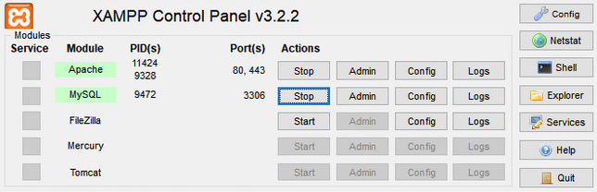

*Figure 3: Xampp*

**Pros:**

* Easy to install and use for beginners.
* Ideal for learning PHP, MySQL, and Apache setup.
* Lightweight for local development environments.

**Cons:**

* Not optimized for production deployment.
* Limited to the traditional LAMP-style tech stack.
* Less scalable for modern web applications.

**Use cases:**

* Legacy systems, WordPress, simple content-based websites, academic projects.

**2. MEVN Stack – Introduction, Analysis & Evaluation**

**MEVN** stands for **MongoDB, Express.js, Vue.js, and Node.js**. It's a full-stack JavaScript-based framework for building modern web applications. All layers use JavaScript, from database (MongoDB) to backend (Express + Node) and frontend (Vue).

  
*Figure 4: MEVN stack*

**Pros:**

* Full JavaScript stack – same language across all layers.
* Highly scalable and suitable for cloud-native apps.
* Great for real-time, SPA (Single Page Applications).

**Cons:**

* Steeper learning curve for beginners.
* Requires more setup than XAMPP.
* Vue.js ecosystem can be fragmented for large projects.

**Use cases:**

* Modern web apps, SPAs, real-time applications, APIs, dashboards.

**3. XAMPP vs MEVN Stack Comparison**

| **Criteria** | **XAMPP** | **MEVN Stack** |
| --- | --- | --- |
| **Technology Stack** | Apache, MySQL, PHP, Perl | MongoDB, Express.js, Vue.js, Node.js |
| **Programming Language** | PHP (backend), SQL | JavaScript (frontend & backend), NoSQL |
| **Architecture** | Traditional monolithic (server-side rendering) | Modern SPA architecture with client-server separation |
| **Ease of Setup** | Very easy, beginner-friendly | Moderate complexity, requires more configuration |
| **Scalability** | Low – suitable for small/local apps | High – supports cloud-native and scalable applications |
| **Use Cases** | WordPress, simple websites, local PHP development | Real-time apps, SPAs, modern web platforms |
| **Database** | MySQL (Relational Database) | MongoDB (NoSQL Database) |
| **Best For** | Learning PHP, basic local development | Full-stack JS development, scalable modern web applications |

1. **Technology discussion:**
2. **backend technology (NodeJS, ExpressJS):**

***NodeJS* :** an environment that runs JavaScript on the server, helping to create backend web applications without using PHP, Java,...

**Architecture**: Event Loop + Non-blocking I/O helps Node handle thousands of requests at the same time without congestion.

**Practical applications:**

* API for web and mobile applications
* Chat system, realtime (using socket.io)
* Server for microservices

**Advantages**

* High performance with lots of I/O
* Same JavaScript language in frontend and backend (fullstack easy to learn)
* Large community → many npm libraries support

**Disadvantages**

* Not suitable for CPU-intensive tasks (because of single-thread)
* Callback hell if you don't know async/await

***ExpressJS:*** is minimalist framework for NodeJS that makes request/response processing easier.

**Basic structure:**

* Router: navigate URL
* Middleware: process data before returning response
* Error handling: handle errors centrally

**Advantages**

* Create REST API quickly
* Easy integration with MongoDB, middleware, JWT, session, etc.

**Disadvantages**

No standard structure available → have to organize code yourself (or use an extended framework like NestJS)

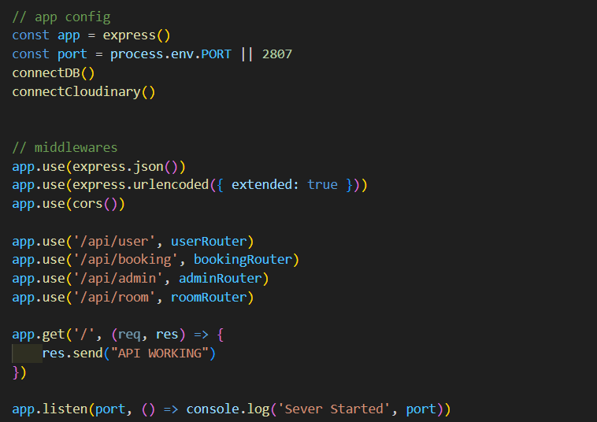  
*Figure 5: Using NodeJS + ExpressJS in code*

**2. Frontend Technology: ReactJS**

**Concept:**

React is a JavaScript library developed by Facebook, used to build UI based on components.

**Features:**

* Component-based: the interface is divided into independent components.
* Uses JSX - a syntax that mixes HTML and JS.
* Virtual DOM helps update quickly and effectively.

**Advantages:**

* Easy to reuse components.
* High performance thanks to Virtual DOM.
* Large community, many supporting libraries.

**Disadvantages:**

* JSX can be difficult to get used to at first.
* Requires a lot of configuration if not using CRA (create-react-app).

**3. Database Technology: MongoDB**

**Concept:**

MongoDB is a NoSQL database management system, storing JSON documents (documents).

**Features:**

* No tables, columns like SQL, but uses collections and documents.
* Flexible data, no need for fixed schema.

**Advantages:**

* Easy to expand.
* Suitable for applications that need to store JSON (like frontend JS).

**Disadvantages:**

* Not strong in complex queries like SQL.
* Lack of data binding (if not using libraries like Mongoose).

**4. Popular Libraries**

| **Library** | **Description** |
| --- | --- |
| **mongoose** | ODM (Object Data Modeling) library for MongoDB and NodeJS. Allows schema definition and interaction with MongoDB. |
| **body-parser** | Parses incoming request bodies. Now built into Express via **express.json()** and **express.urlencoded().** |
| **axios** | Promise-based HTTP client for the browser and NodeJS. Used to communicate between frontend and backend. |
| **cors** | Middleware that enables CORS (Cross-Origin Resource Sharing) to allow frontend apps from different domains to access the backend APIs. |

**5. Tools Used**

| **Tool** | **Purpose** |
| --- | --- |
| **Visual Studio Code (VS Code)** | Lightweight yet powerful code editor with great extension support. |
| **Studio 3T** | GUI tool to manage and query MongoDB databases. |
| **Postman** | API testing tool to send requests and view responses without needing to build a frontend. |

**6. Cloud Technologies**

| **Platform** | **Use** |
| --- | --- |
| **MongoDB Atlas** | Cloud-hosted MongoDB service with free tier, secure connection, and backups. |
| **Render** | Cloud platform to host backend services (NodeJS, Express, etc.), supports auto-deploy from GitHub. |
| **Vercel** | Platform to deploy frontend apps (React, Next.js), optimized for performance and SEO. |
| **Cloudinary** | Cloud-based media management service that stores, optimizes, and delivers images and videos. |

**V. Evaluation**

## **1**. **Pros of the Demo Web System**

The demo web system demonstrates a solid foundation using modern web development technologies. It reflects a real-world architecture where frontend, backend, database, and cloud services are integrated seamlessly.

* **Modern tech stack**: The system uses React for the frontend and NodeJS + Express for the backend, providing a responsive and fast user experience.
* **Fullstack functionality**: It includes key features such as user registration, login, booking functionality, and interaction with the database, showcasing a complete data flow.
* **Cloud deployment**: Using services like Vercel (for frontend), Render (for backend), and MongoDB Atlas (for database) allows the application to be accessible online with minimal configuration.
* **Image hosting**: Integration with Cloudinary enables efficient media upload, transformation, and delivery without stressing the local server.
* **RESTful APIs**: The backend follows REST principles, making the API easy to test and extend.
* **Good data handling**: With Mongoose managing MongoDB, the app benefits from schema validation and an intuitive interface for database operations.
* **User-friendly interface**: React’s component-based design makes the UI dynamic and reusable, while offering fast rendering thanks to the Virtual DOM.

## **2. Cons of the Demo Web System**

While the demo system is functional and impressive for a prototype, it also has limitations that are common in early-stage or academic projects.

* **Limited features**: It may not cover all possible use cases such as admin management, payment gateways, or detailed error validation.
* **Security concerns**: The system might lack advanced security measures such as password encryption, JWT expiration handling, and protection against attacks like XSS or CSRF.
* **Basic design**: The UI/UX may be simple and not yet polished for a production-level application.
* **No testing**: The project may not include unit testing or integration testing, making it harder to ensure stability when adding new features.
* **Performance optimization**: Features like lazy loading, caching, or CDN usage (beyond Cloudinary) may not be implemented.
* **Scalability**: The app is suitable for a small number of users but not optimized for high traffic or concurrent bookings.
* **Error handling**: Error messages and form validations may be minimal, making the app harder to debug or less user-friendly in edge cases.
* **Responsiveness**: Without specific attention to mobile design, the layout might not adapt well on all screen sizes.

**VI. Conclusion**

In conclusion, this report has outlined the design, technology stack, and functionalities of a modern web application built for booking homestays. By leveraging the MEVN stack—MongoDB, ExpressJS, VueJS, and NodeJS—alongside cloud services like MongoDB Atlas, Render, and Vercel, the system demonstrates a fully functional full-stack project. Through this experience, I gained valuable knowledge in developing RESTful APIs, managing databases with Mongoose, building responsive interfaces with modern JavaScript frameworks, and deploying applications to the cloud. This project not only helped me improve my technical skills but also gave me insight into building real-world, scalable applications using current industry technologies.

**VII. Future recommendations**

In the future, there are several potential improvements that can enhance the demo web system. First, implementing advanced security measures such as password hashing, token expiration, and protection against common web vulnerabilities (XSS, CSRF) would make the system more robust. Adding a complete admin dashboard with full CRUD operations for users and bookings would also improve system control and usability.

Moreover, integrating a real payment gateway like Stripe or PayPal could enable actual transaction processing. On the frontend, improving the user interface with modern UI libraries and ensuring full responsiveness across devices would enhance the user experience. Additionally, incorporating testing frameworks such as Jest or Mocha for unit and integration testing would ensure the system’s stability and reliability. Lastly, applying CI/CD pipelines for automatic deployment and considering serverless architecture or containerization (e.g., Docker) could prepare the project for large-scale, production-level deployment.

**VIII. References**

**Theory Sources:**

* Date, C. J. (2012). *Database Systems: A Practical Approach to Design, Implementation, and Management*. 6th ed. Boston: Addison-Wesley.
* Stonebraker, M. (2014). 'Relational Databases and NoSQL', *ACM Computing Surveys*. 46(2), pp. 1-30. DOI: 10.1145/2560083.
* Ullman, J. D., and Widom, J. (2011). *A First Course in Database Systems*. 3rd ed. Upper Saddle River, NJ: Prentice Hall.

**Additional Sources:**

* Khan, R. (2023). 'Comparing MongoDB with Relational Databases: Advantages and Disadvantages', *Tech Times*. Available at: https://www.techtimes.com/articles/mongodb-vs-rdbms [Accessed 22 Apr. 2025].
* Nguyen, T. (2023). 'Web Development with MEVN Stack: A Complete Guide', *Web Development Blog*. Available at: https://www.webdevblog.com/mevn-stack-guide [Accessed 22 Apr. 2025].

**IX. Appendices**

**1. Evidence of weekly lab tasks**

**1.1 Tutorial 5**

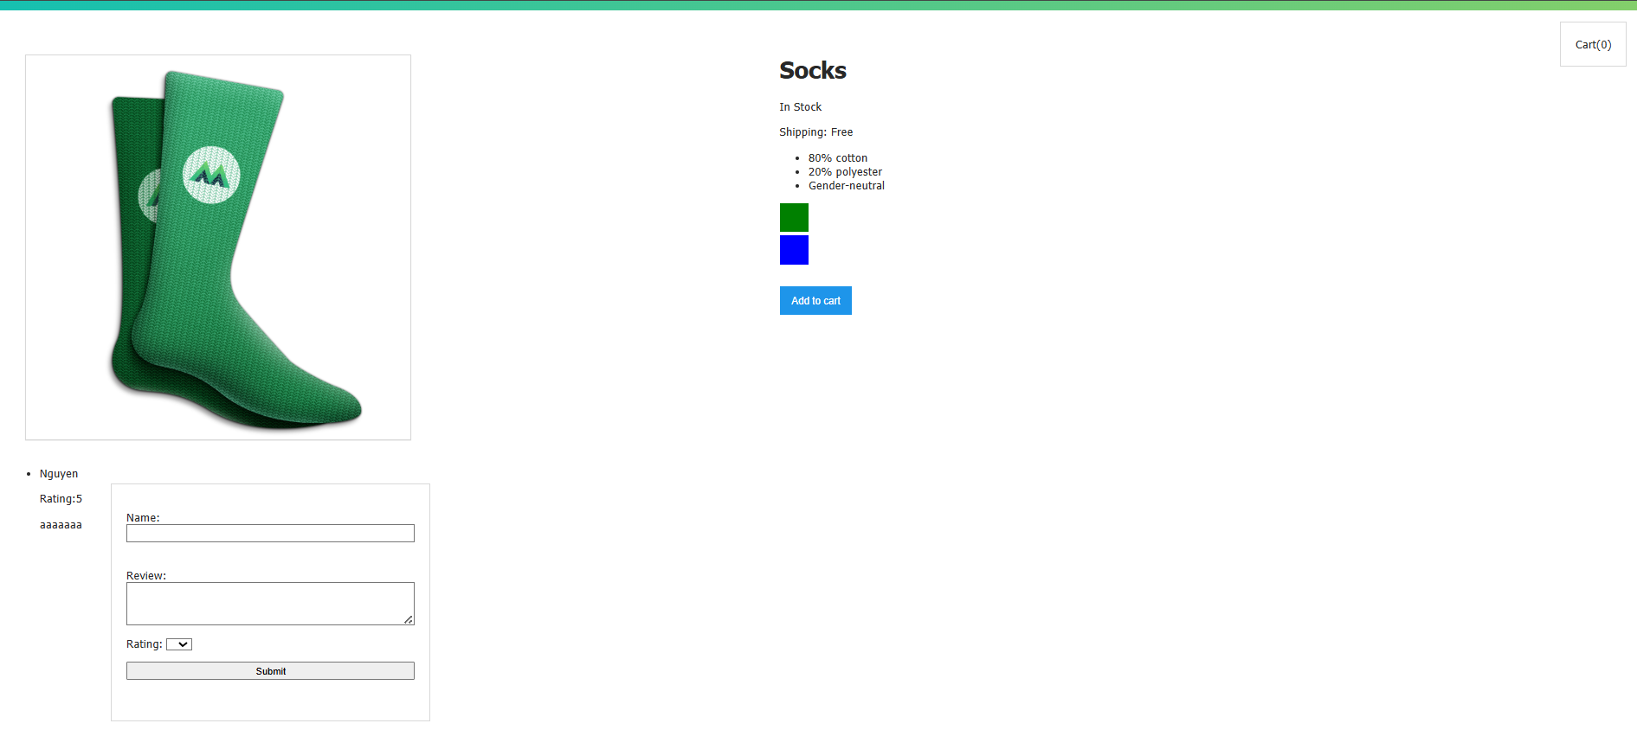

*Figure 6: Green Socks image*

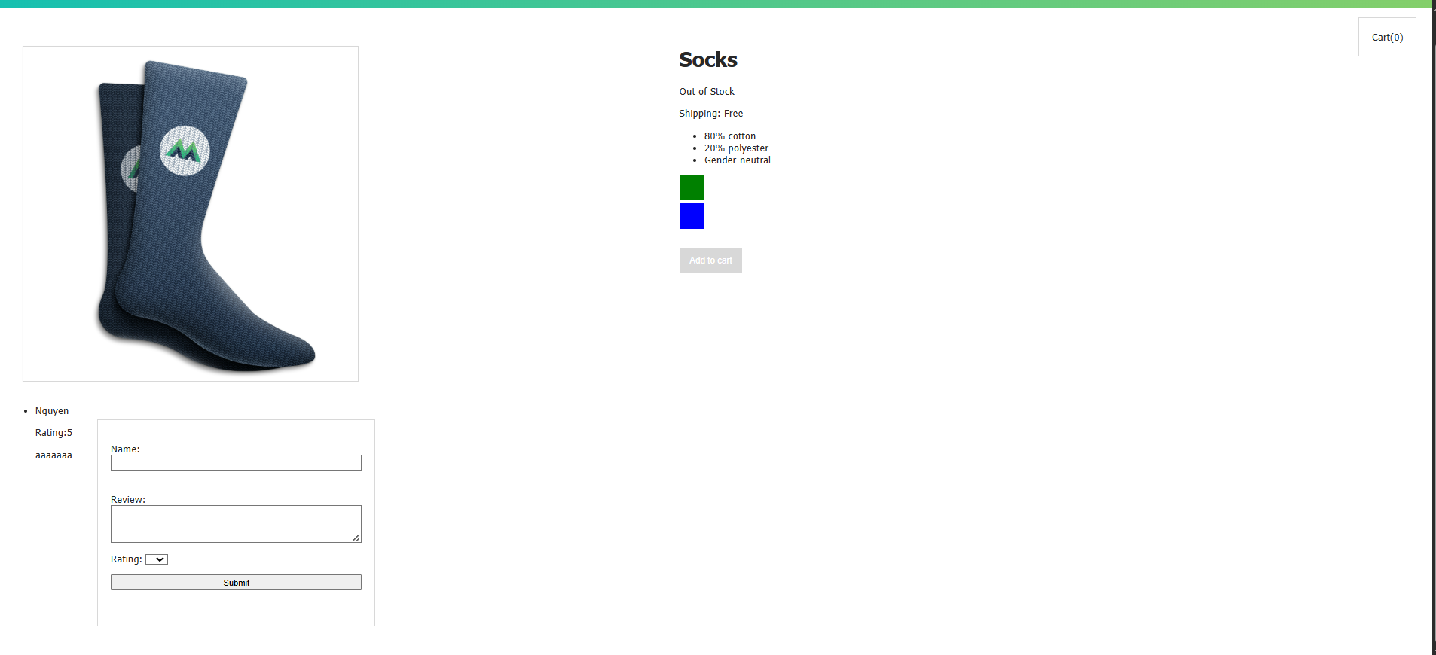

*Figure 7: Blue Socks image*

This report presents a comprehensive overview of the weekly lab tasks conducted as part of the web/software development module. Each lab session was designed to build foundational knowledge and practical experience in front-end development, component interaction, and dynamic content rendering using modern frameworks such as **Vue.js** or **React**.

The appendices section provides visual documentation through **screenshots**, **code snippets**, and **annotations**, demonstrating the progression of the lab exercises. Each lab is accompanied by detailed commentary, explaining its purpose, the techniques applied, and the learning outcomes achieved.

The selected screenshots in this report — such as the product page interface for a sock item — reflect the implementation of interactive elements like dynamic stock status, color variations, and review submissions. These labs contribute significantly to the student’s ability to develop responsive, user-friendly interfaces, aligning with industry standards in e-commerce platforms and real-world applications.

**1.2 Tutorial 8**

The above image illustrates the workflow of working with JSON data about Scottish pubs in MongoDB. The first image shows the user using Studio 3T software to build a query pipeline, specifically using the $project stage to select and reformat the necessary data fields. The second image shows the result after the data from the JSON file has been successfully imported into MongoDB, clearly displaying fields such as pub name, address and identifier (fsa_id), allowing the user to easily query and analyze. The last image is an image of the folder on the computer, containing the scottish_pubs.json file with a capacity of over 2MB, which is the data source used in the above process.

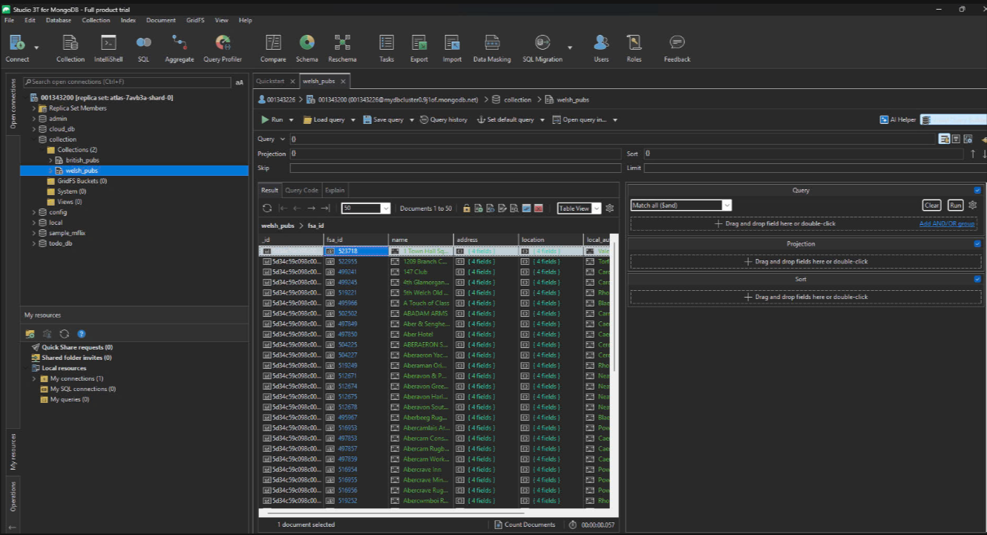

*Figure 8: 3T image-1*

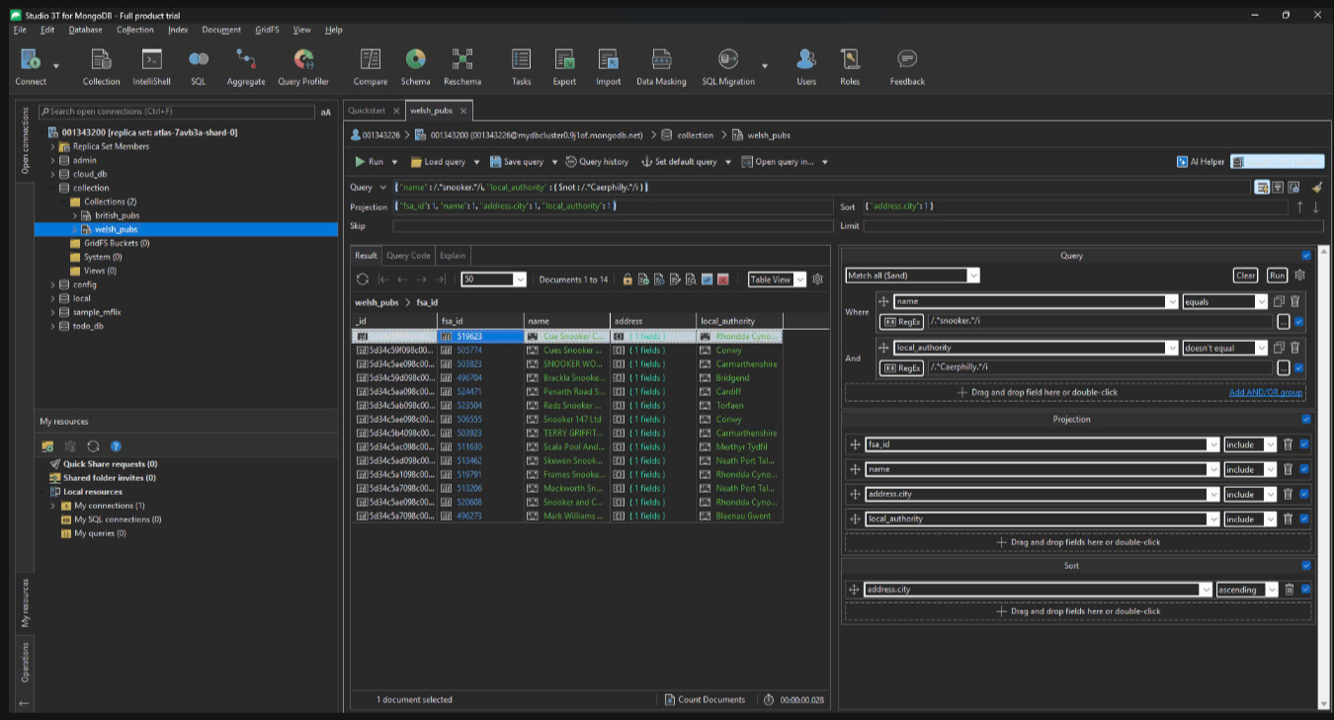

*Figure 9: 3T image-2*

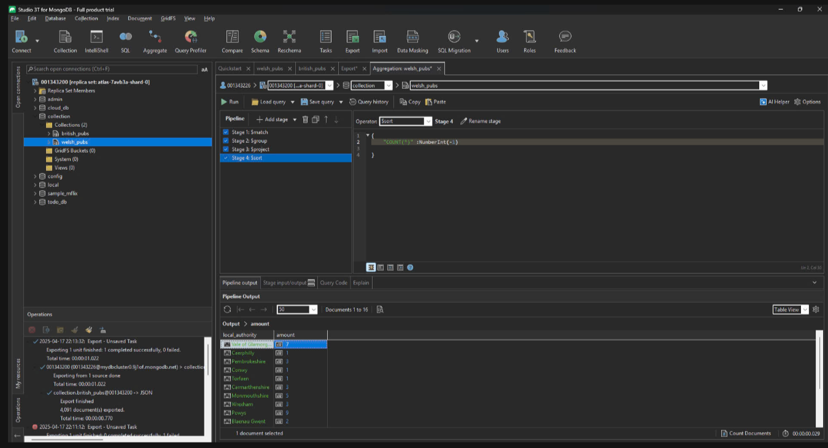

*Figure 10: 3T image-3*

**1.3 Tutorial 9**

The web application created with Node.js uses the pure http module, listens at http://localhost:2874 and responds based on the URL the user accesses.

When accessing /, the browser displays the text “This is Home page” in red.

When accessing /student, it displays “This is Student page” in the same format.

Similarly, accessing /admin displays “This is Admin page”.

Accessing /greenwich returns a JSON response: { "university": "Greenwich VietNam" }.

If the user enters a URL that does not match any of the routes, the system returns an “Invalid Request” message.

All the processing logic is written in the if-else structure in the http.createServer function, demonstrating basic routing without using a framework like Express. This is a typical example to understand how a pure HTTP server works in Node.js.

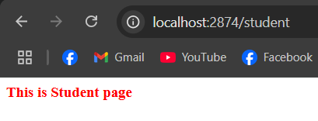

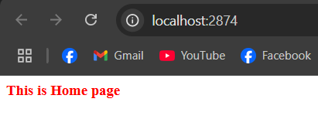

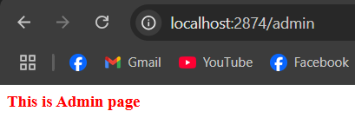

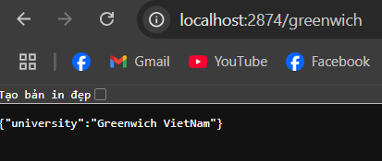

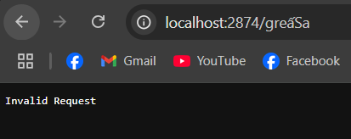

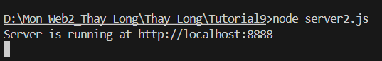

*Figures 11: 6 images for tutorial 9*

**1.4 Tutorial 10**

The project in Tutorial10 is a practice lesson in the Web Programming 2 course, designed to help students master advanced web programming concepts and skills. The content of the practice lesson focuses on building and implementing web features, which may include:

Developing user interfaces (UI): Using HTML, CSS, and JavaScript to create interactive interfaces.

Handling client-side or server-side logic: Applying frameworks or libraries such as React, Angular, or Node.js.

Connecting to databases: Practicing storing and retrieving data from databases such as MongoDB, MySQL, or Firebase.

Implementing APIs: Building RESTful APIs to communicate between clients and servers.

This project not only helps students consolidate theoretical knowledge but also develops practical skills, preparing for practical applications in web programming

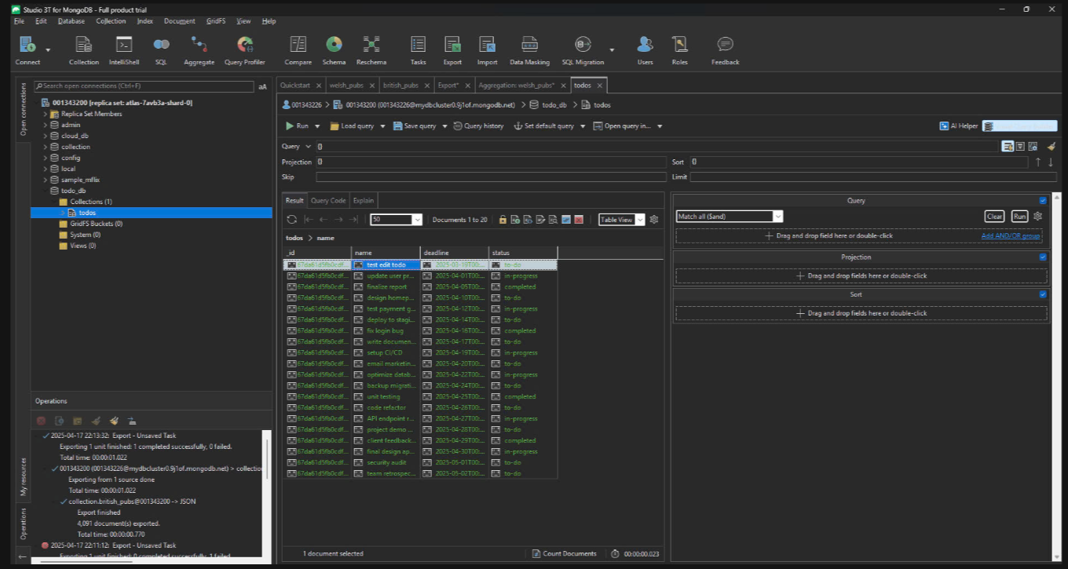

*Figures 12: image for tutorial 10*

**2. Evidence of demo web system**

In this report, I will present the direction of website design with the main language being front-end React + JS and using database with MongoDB.

The website overview will be about the topic of booking (booking Homestay), the website meets all the requirements of CRUD (Create, Read, Update, Delete) and divides roles for users and administrators. On the user side, they can login/register, view information on the Home page, view room details and make bookings directly on the website by check-in time, checkout and number of guests, pay directly on the web and view booking history. On the admin side, I will provide an available account to directly manage the website including main functions such as room management, adding rooms, editing and deleting rooms, in addition to functions such as user management, which can delete and view booking history including the booker's email and booking information.

That's an overview of the site I'll go into more detail below and also how the site operates via MongoDB and React + JS.

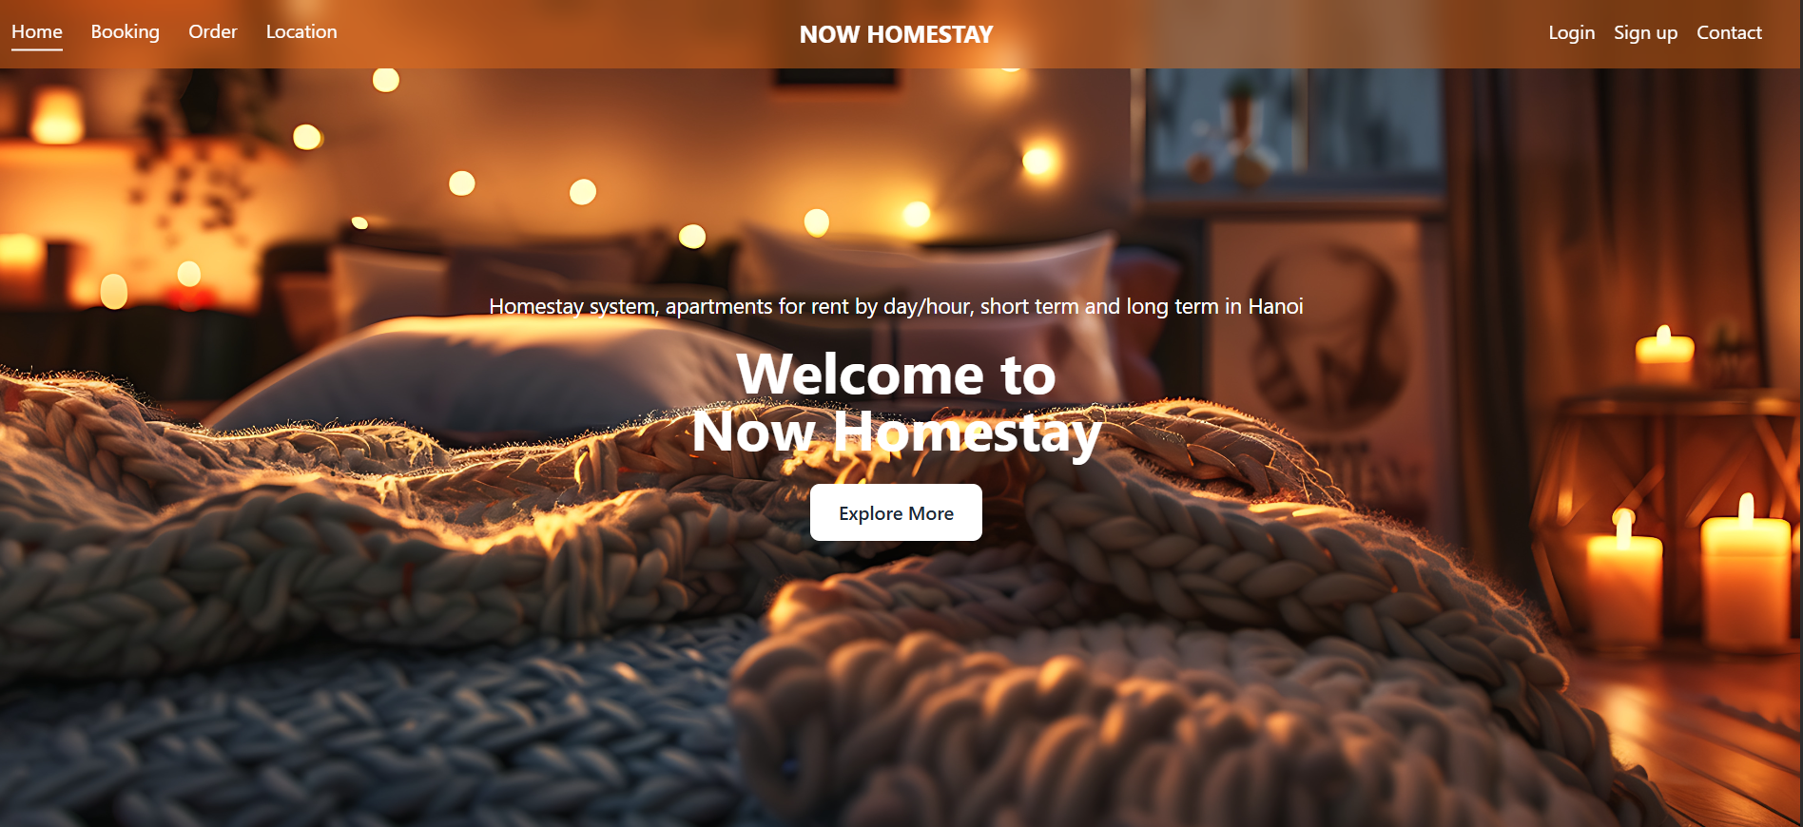

*Figure 13: Home page*

**1. Frontend (React)**

**Basic:**

* react: Main library for building user interfaces.
* react-dom: Render React into DOM.
* react-router-dom: Manage navigation between pages.
* vite: Quick build tool for React.

**Interface and effects:**

* tailwindcss: Convenient CSS framework for building interfaces.
* framer-motion: Create motion effects for interface components.
* swiper: Create slider/carousel for sections like room list.
* react-datepicker: Date picker library for booking form.
* lucide-react: Lightweight and easy-to-use SVG icon set.
* react-icons: Popular icon set for use in interfaces.

**Notifications and state handling:**

* sonner: Display notifications (toast notifications).
* axios: HTTP API call library.
* react-context: Manage global state using Context API.

**Map:**

* react-leaflet: Displays a map based on OpenStreetMap.
* leaflet: The map library used by React Leaflet.

**2. Backend (Node.js + Express)**

**Basic:**

* express: Framework for building RESTful APIs.
* dotenv: Manage environment variables (e.g. MongoDB, Cloudinary connections).
* cors: Enable communication between frontend and backend (CORS).
* body-parser: Parse data from request body.

**Database:**

* mongoose: Library for interacting with MongoDB.
* Authentication and security:
* jsonwebtoken: Generate and validate JWT (JSON Web Token).
* bcrypt: Encrypt user passwords.
* File upload and management:
* multer: Middleware for handling file uploads.
* cloudinary: SDK for managing images on Cloudinary.

**Data validation and processing:**

* validator: Validate data (email, phone number, etc.).
* express-validator: Middleware for validating data in requests.

**A. User side details**

**1. Login ( User & Admin )**

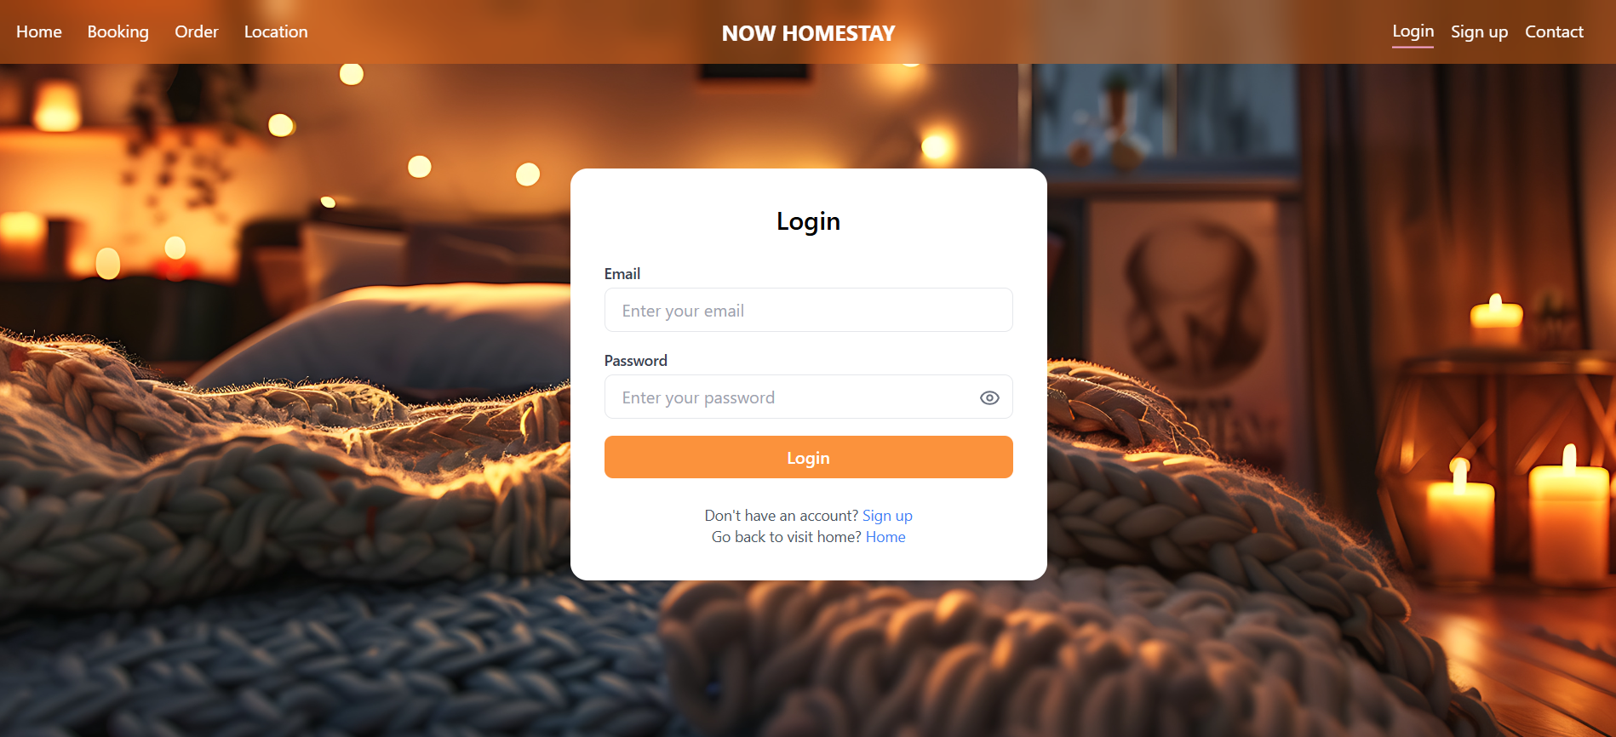

*Figure 14: Login page*

Component Login handles the login process for users and admins in the NOW HOMESTAY system. When the user enters the email and password, the loginHandle will be called when submitting the form:

If the **email** is **hipngu@gmail.com**, the system considers it as admin and sends a request to the API **/api/admin/login**, otherwise it is **/api/user/login**.

After successful login:

If admin: redirect to the admin page **/admin/view_room**, save the atoken to localStorage and context.

If user: redirect to the home page **/ (home page),** save the corresponding **access_token**.

If the login fails, an error message will be displayed via the toast library.

The interface uses Tailwind CSS, allowing to hide/show passwords using LuEye and LuEyeClosed icons, along with beautiful background images and designs. All state (email, password, showPassword) is managed with useState, and navigation with useNavigate.

**1.1 Login success with User Account:**

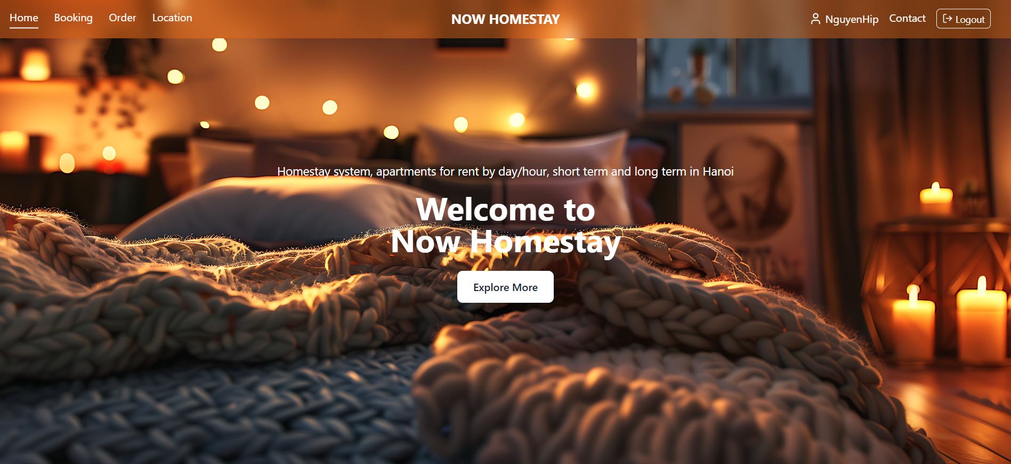

*Figure 15: User Home Page*

The **Home** page of the NOW HOMESTAY website serves as a welcoming landing page for users. It features:

* A large **hero banner** with a cozy homestay background, including candles and blankets to evoke warmth and comfort.
* A **top navigation bar** with links to Home, Booking, Order, and Location, as well as user info (e.g., *NguyenHiep*), Contact, and Logout buttons.
* A central **welcome message** ("Welcome to Now Homestay") and an **"Explore More"** button to guide users further down the page.
* A brief description of the service: “Homestay system, apartments for rent by day/hour, short term and long term in Hanoi.”

Overall, the page provides a strong first impression with a visually appealing design and intuitive navigation, helping users quickly understand the brand and explore the platform.

**1.2 Login success with Admin Account:**

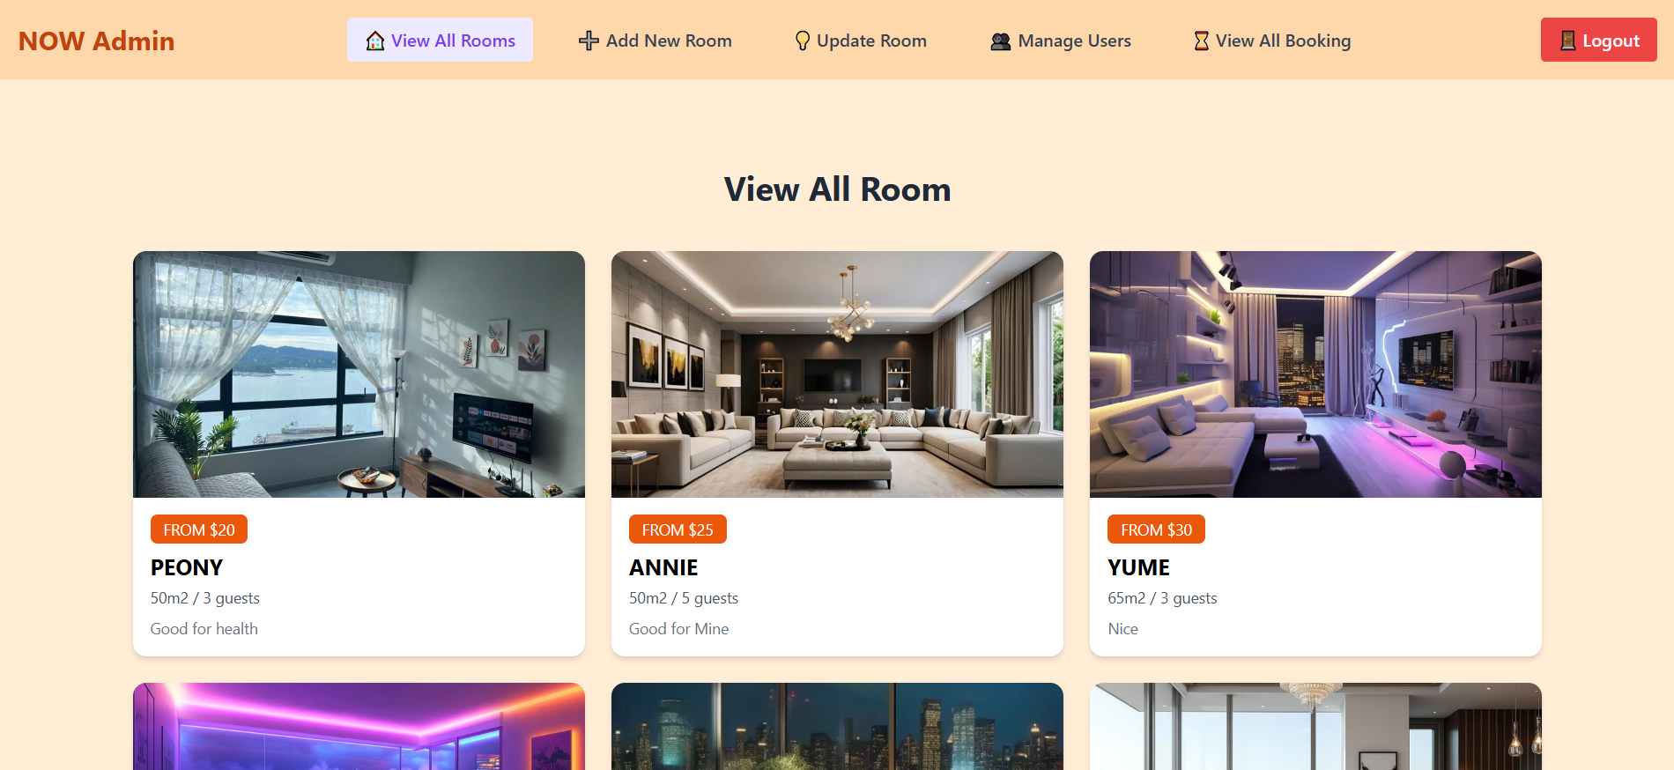

*Figure 16: Admin Home page*

The **Admin "View All Room"** page of the NOW HOMESTAY platform provides a comprehensive and organized interface for administrators to manage room listings. It includes:

* A **navigation bar** at the top with options like View All Rooms, Add New Room, Update Room, Manage Users, View All Booking, and a Logout button.
* The title **"View All Room"** is centered at the top of the main section for clarity.
* Below the title is a **grid layout** displaying all available rooms, each in a card format that includes:
  + Room name (e.g., PEONY, ANNIE, YUME)
  + Size (e.g., 50m²), capacity (e.g., 3 guests)
  + Description or notes (e.g., “Good for health”, “Nice”)
  + A price tag label (e.g., FROM $0, FROM $5)

This admin page is visually clean and functional, allowing administrators to easily oversee and manage all room listings in one place.

**2. View homepage:**

**2.1 home.jsx**



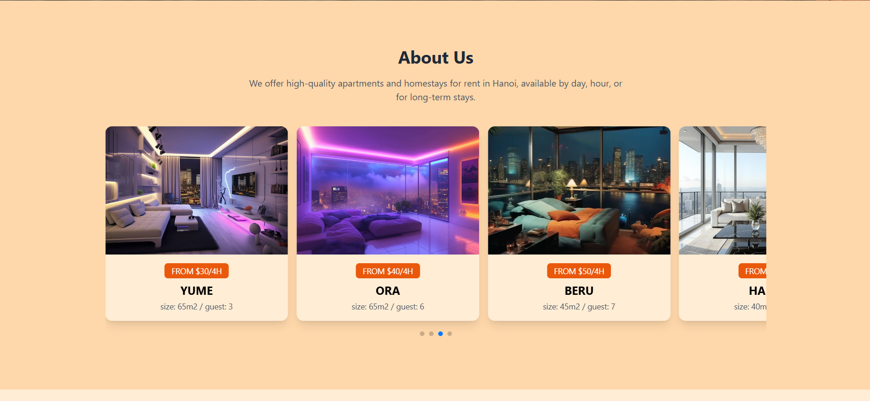 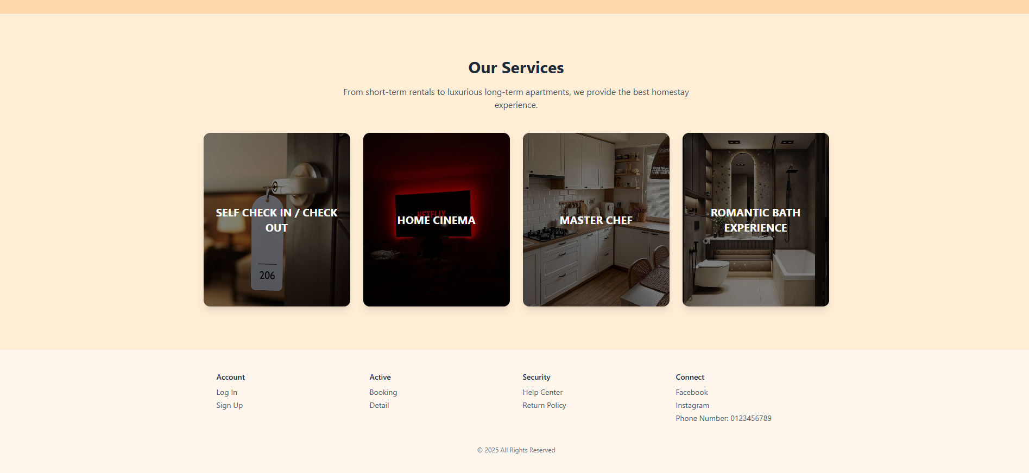

*Figure 17: All user home page*

The **Home** component is the main landing page of NOW HOMESTAY, built with **React**, **Framer Motion**, **Swiper**, and **Axios** to provide a modern and interactive experience. It features a hero section with a welcome message and scroll button, an "About Us" section with a room slider, and an "Our Services" section highlighting key amenities like self check-in, in-room cinema, and more.

Room data is fetched from the backend using useEffect and displayed in a responsive Swiper slider. The component manages state with useState for rooms, loading, and errors. Interactive hover effects in the service section enhance user engagement. Overall, it offers a clear and engaging introduction to NOW HOMESTAY's offerings.

**2.2 booking.jsx**

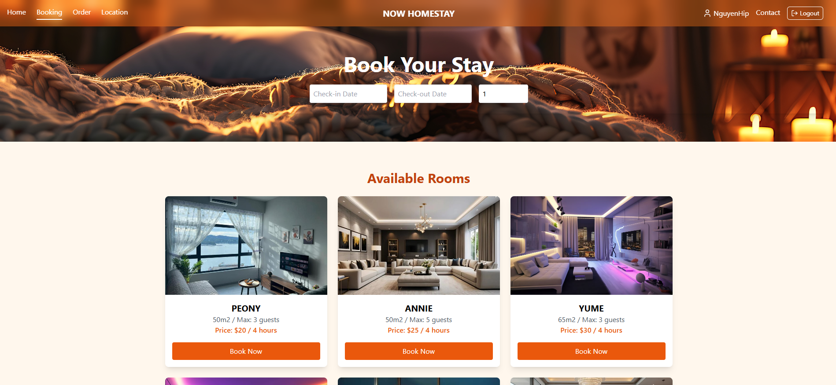

*Figure 18: Booking page*

The Booking component is part of NOW HOMESTAY's booking system, built with React and Framer Motion. It allows users to select check-in/check-out dates and the number of guests, displaying available rooms fetched from the backend using Axios. The rooms are shown in a responsive grid with hover effects, and users can click "Book Now" to navigate to a room's details. State management is handled with useState, and loading and error states are displayed when necessary. Toast notifications are used for user feedback.

**2.3 roomDetail.jsx**



*Figure 19: RoomDetail page*

The RoomDetail component is part of **NOW HOMESTAY's booking system**, built using **React** and **Framer Motion**. It displays detailed information about a specific room, including images, room size, capacity, and price. Users can select their check-in/check-out dates and the number of guests, with validation and real-time updates.

Room details are fetched dynamically from the backend using **Axios**, based on the room name in the URL. The UI includes interactive elements like a date picker (react-datepicker) and animated transitions for a smooth user experience. Users can click **"Book Now"** to navigate to the cart with selected booking details.

**State is managed with useState**, and the app handles **loading and error states**. Toast notifications via **Sonner** provide user feedback for success, warnings, and errors. The page also features an image gallery with motion effects and a call-to-action to view more rooms.